

***Front-End Essentials***

**Lab Guides**

|  |  |
| --- | --- |
| Document Code | 25e-BM/HR/HDCV/FSOFT |
| Version | 1.1 |
| Effective Date | 20/11/2012 |

**Hanoi, 04/2019**

RECORD OF CHANGES

|  |  |  |  |  |  |
| --- | --- | --- | --- | --- | --- |
| No | Effective Date | Change Description | Reason | Reviewer | Approver |
|  | 25/Jun/2018 | Create a new Lab | Create new | DieuNT1 | VinhNV |
|  | 01/May/2019 | Update Fsoft Template | Update | DieuNT1 | VinhNV |
|  |  |  |  |  |  |
|  |  |  |  |  |  |
|  |  |  |  |  |  |
|  |  |  |  |  |  |
|  |  |  |  |  |  |
|  |  |  |  |  |  |
|  |  |  |  |  |  |
|  |  |  |  |  |  |

Contents

Unit 2 – Bootstrap 4 5

Objectives 5

Technical Requirements: 5

Specifications: 5

Guidelines: 6

Step 1: Create project structure 6

Step 2: Open project in IDE 6

Step 3: Create basic HTML5 documents 6

Step 4: Open Web site 11

|  |  |
| --- | --- |
|  | **CODE: FEE.M.L202 (Bootstrap 4)**  **TYPE: Medium**  **LOC: 200**  **DURATION: 90 MINUTES** |

# Unit 2 – Bootstrap 4

Objectives

* Understand the core concepts of Bootstrap (layout, rows, grid, flex, components: buttons, alerts, utilities)
* Able to create complex, beautiful, responsive webpage with Bootstrap

Technical Requirements:

* Must use HTML, CSS, and Bootstrap 4

Specifications:

You have to build a Employee Management Webpage using HTML, CSS and Bootstrap 4.

The app is composed of 6 sections:

1. A Header: on the left is the Brand Name, and on the right side is 4 links: Home Page, Add an Employee, List Employes, Account information. If user click on any of 4 links, the corresponding section must be shown (i.e click on Contact will show Contact section)
2. Home section: a brief overview about the web site
3. Body section: Add an Employee or List Employees
4. Footer section

See figure below to understand better the app:

* **home-page.html** Screen:

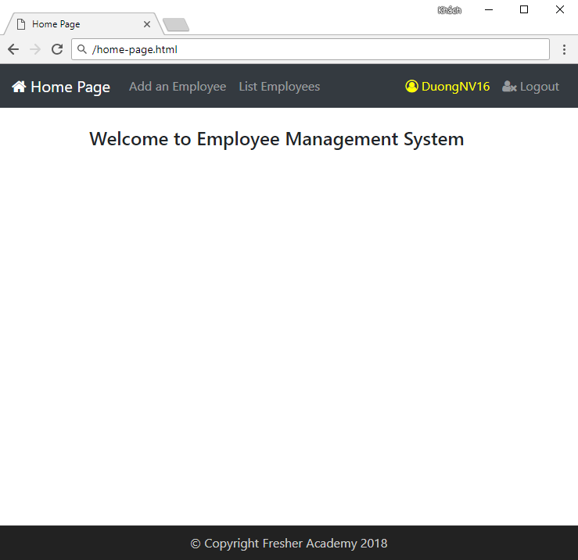

Guidelines:

Step 1: Create project structure

Create the project structure like figure below:

|  |
| --- |
|  |

Step 2: Open project in IDE

Open the newly created project using Visual Studio Code

Step 3: Create basic HTML5 documents

Open file index.html in VSC (Visual Studio Code), and type in html VSC will show a list of suggestions.

Choose html:5 and press Enter

**Link Bootstrap 4:**

<link rel="stylesheet"

href="https://maxcdn.bootstrapcdn.com/bootstrap/4.1.0/css/bootstrap.min.css">

**Link Font Awesome:**

<link rel="stylesheet" href="https://cdnjs.cloudflare.com/ajax/libs/font-awesome/4.7.0/css/font-awesome.min.css">

* **Source code:**

1. <html>
2. <head>
3. <meta http-equiv="Content-Type" content="text/html; charset=ISO-8859-1"
4. name="viewport" content="width=device-width, initial-scale=1">
5. <link rel="stylesheet"
6. href="https://maxcdn.bootstrapcdn.com/bootstrap/4.1.0/css/bootstrap.min.css">
7. <link rel="stylesheet"
8. href="https://cdnjs.cloudflare.com/ajax/libs/font-awesome/4.7.0/css/font-awesome.min.css">
9. <title>Home Page</title>
10. </head>
11. <body>
12. <nav class="navbar navbar-expand-sm navbar-dark bg-dark">
13. <a class="navbar-brand" href="#">
14. <i class="fa fa-home"></i> Home Page
15. </a>
16. <div id="navbarNavDropdown" class="navbar-collapse collapse">
17. <ul class="navbar-nav mr-auto">
18. <li class="nav-item">
19. <a class="nav-link" href="#" id="addEmpLink">Add an Employee</a>
20. </li>
21. <li class="nav-item">
22. <a class="nav-link" id="listEmpsLink" href="#">List Employees
23. </a>
24. </li>
25. </ul>
26. <ul class="navbar-nav ml-auto">
27. <li class="nav-item">
28. <a class="nav-link" style="color: yellow" href="#">
29. <i class="fa fa-user-circle-o"> DuongNV16 </i>
30. </a>
31. </li>
32. <li class="nav-item">
33. <a class="nav-link" href="../logout">
34. <i class="fa fa-user-times"></i> Logout
35. </a>
36. </li>
37. </ul>
38. </div>
39. </nav>
40. <div class="container">
41. <h4>Welcome to Employee Management System</h4>
42. </div>
43. <div class="row fixed-bottom" style="border-top: 1px solid #ccc; background-color: #222">
44. <div class="col-md-12">
45. <p style="margin: 10px auto; text-align: center; color: #ccc">&copy;
46. Copyright Fresher Academy 2018
47. </p>
48. </div>
49. </div>
50. </body>
51. </html>

* **add-employee.html** Screen**:**

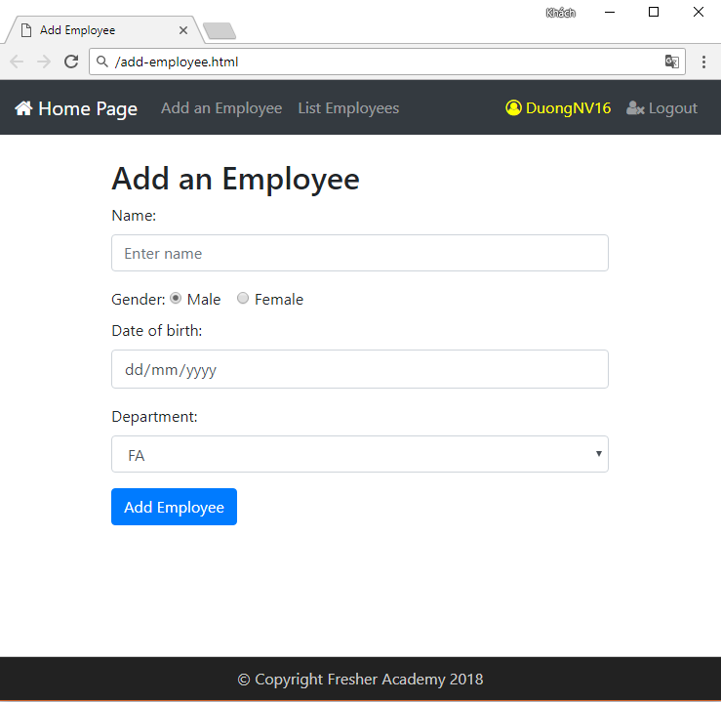

Replace the content of line 57 at the <div> tag with the following content:

1. <div class="container">
2. <h4>Welcome to Employee Management System</h4>
3. </div>

* **Source code:**

1. <form action="#" method="post" name="frm-addEmp">
2. <div class="row">
3. <div class="col-md-6 offset-md-3">
4. <h2>Add a Employee</h2>
5. <div class="form-group">
6. <label for="employeeName">Name:</label>
7. <input type="text" class="form-control" id="employeeName"
8. placeholder="Enter name" name="employeeName">
9. </div>
10. <label for="gender">Gender:</label>
11. <div class="form-check-inline">
12. <label class="form-check-label">
13. <input type="radio" class="form-check-input"
14. name="gender" value="1" checked>Male
15. </label>
16. </div>
17. <div class="form-check-inline">
18. <label class="form-check-label">
19. <input type="radio" class="form-check-input"
20. name="gender" value="0">Female
21. </label>
22. </div>
23. <div class="form-group">
24. <label for="dateOfBirth">Date of birth:</label>
25. <input type="date" class="form-control" id="dateOfBirth"
26. placeholder="Enter date of birth" name="dateOfBirth">
27. </div>
28. <div class="form-group">
29. <label for="dept">Department:</label>
30. <select class="form-control" id="dept"></select>
31. </div>
32. </div>
33. </div>
34. <div class="row">
35. <div class="col-md-6 offset-md-3">
36. <button type="button" id="btn-addEmp" class="btn btn-primary">
37. Add Employee
38. </button>
39. </div>
40. </div>
41. </form>

* **list-employees.html** Screen**:**

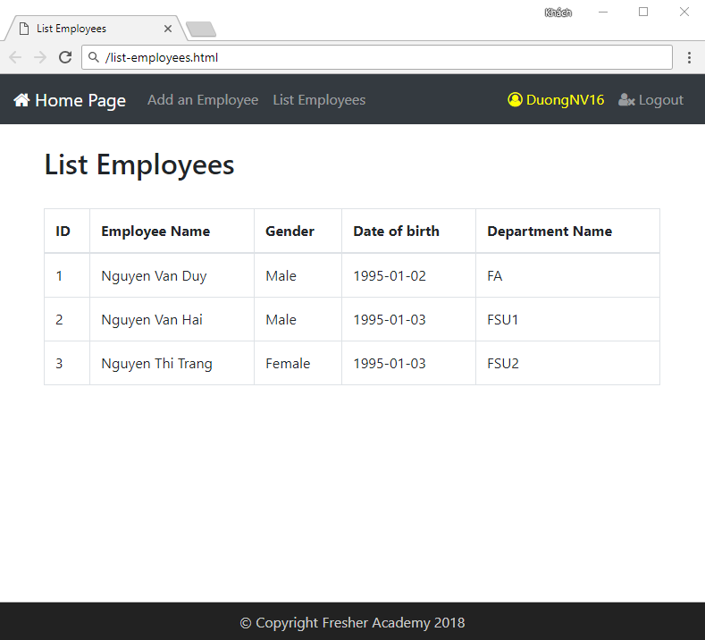

Continue, replace the content of line 57 at the <div> tag with the following content:

1. <div class="container">
2. <h4>Welcome to Employee Management System</h4>
3. </div>

* **Source code:**

1. <h2>List of Employees</h2>
2. <br />
3. <table class="table table-bordered">
4. <thead>
5. <tr>
6. <th>ID</th>
7. <th>Employee Name</th>
8. <th>Gender</th>
9. <th>Date of birth</th>
10. <th>Department Name</th>
11. </tr>
12. </thead>
13. <tbody>
14. <tr>
15. <td>E101</td>
16. <td>Nguyen Van Khoa</td>
17. <td>Male</td>
18. <td>01/01/1990</td>
19. <td>Fresher Academy</td>
20. </tr>
21. </tbody>
22. </table>

Step 4: Open Web site

Right-click on index.html file and click Open with Live Server

Note: You must install Live Server extension of VSC

|  |
| --- |
|  |

**Step 14: Verify and tweak**

Open the app using Live Server, you should have the same layout like figure below:



The app looks pretty much like the design!

**-- THE END --**